ELECTRONIC CONFIGURATION

Electronic Configuration and the Periodic Table
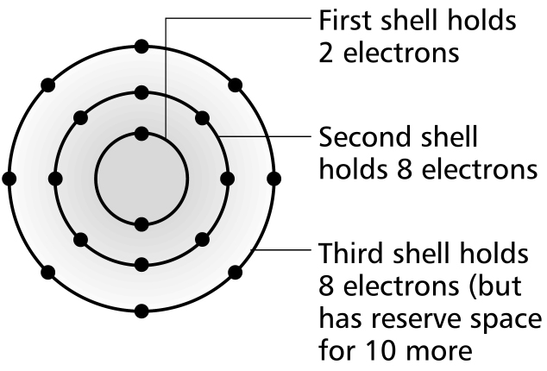
Exercise A

Complete the electronic configuration for the elements with atomic numbers 13, 18, 20
Element | Electronic Configuration
Aluminium | 2, 8, 3
Argon | 2, 8, 8
Calcium | 2, 8, 8, 2

1 2 3 4 5 6 7 8 or 0

He
2

H
1

1
Ne
2,8
F
2,7
O
2,6
N
2,5
C
2,4
B
2,3
Be
2,2
Li
2,1

2

Ar
2,8,8
Cl
2,8,7
S
2,8,6

Si
2,8,4

Mg
2,8,2
Na
2,8,1
3

K
2,8,8,1

4

- A new energy level or shell is started at the beginning of each new Period.

- Period number is

- Group number is .

Exercise B

Complete the following questions about the first twenty elements of the Periodic Table
- Which elements have atoms with 2 electrons in their outer shell?
Helium, Beryllium, Calcium

- Which element has an atom with just one electron in it’s third shell?
Sodium

- Which element is in Period 2 and has atoms with seven electrons in the outer shell?
Fluorine

- Write the electronic configuration for:
  - an atom of an element with atomic number 15
Phosphorus – 2, 8, 5
  - an ion formed by the element with atomic number 15
2, 8, 8 or 2, 8

Energy levels / shells

- n = 1

- n = 2

- n = 3

Shells and Sub-shells

- Shells are divided into subshells .
- These sub-shells are called s, p, d, f.

Evidence for this comes from looking more closely at the successive Ionisation Energy data across any single period of the Periodic Table (see later).

The ‘ s ’ sub-shell holds a maximum of 2 electrons

The ‘ p ’ sub-shell holds a maximum of 6 electrons

The ‘ d ’ sub-shell holds a maximum of 10 electrons

The ‘ f ’ sub-shell holds a maximum of 14 electrons

Principal Quantum Shell | Sub-shells | Total number of electrons 2n²
n = 1 | 1s, | 2
n = 2 | 2s, 2p | 8
n = 3 | 3s, 3p, 3d | 18
n = 4 | 4s, 4p, 4d, 4f | 32

Blocks in the Periodic Table

The Periodic Table can be separated into the s, p, d and f blocks as seen below.

s block

2

p
block

6

d
block

10

f
block
14

Order of filling of sub-shells

- The rule for filling sub-shells with electrons is to start with the lowest energy available sub-shell.
- The sub-shells can be seen below in increasing order of energy.

4p
3d
4s
Increasing energy
3p
3s
2p
2s
1s

An important rule is that due to the 4s sub-shell having lower energy than the 3d sub-shell it is filled first

Order of filling:

1s, 2s, 2p, 3s, 3p, 4s, 3d, 4p

Exercise B

Writing the electronic configuration for atoms and ions

1 Write the electronic configuration using sub-shells for the following atoms and ions:

(a) ₁₁Na 2, 8, 1 - 1s²2s²2p⁶3s¹

(b) Sulfur atom 2, 8, 6 - 1s²2s²2p⁶3s²3p⁴

(c) ₁₉K 2, 8, 8, 1 - 1s²2s²2p⁶3s²3p⁶4s¹

(d) ₂₆Fe 2, 8, 14, 2 - 1s²2s²2p⁶3s²3p⁶4s²3d⁶

(e) Krypton atom 2, 8, 18, 2 - 1s²2s²2p⁶3s²3p⁶4s²3d¹⁰4p⁶

(f) ₃₃As³⁻ 2, 8, 18, 2 - 1s²2s²2p⁶3s²3p⁶4s²3d¹⁰4p⁶

(g) ₃₈Sr²⁺ 2, 8, 18, 2 - 1s²2s²2p⁶3s²3p⁶4s²3d¹⁰4p⁶

2 (a) Why is sodium described as an ‘s’ block element?
The last subshell filled is an s sub-shell

- Why is sulfur described as a ‘p’ block element?
The last subshell filled is a p sub-shell

- Why is iron described as a ‘d’ block element?
The last subshell filled is a d sub-shell

Isoelectronic Configuration
Some of the above atoms and ions have electronic configurations which are isoelectronic
with one another.

Suggest what this may mean.
They have the same number of electrons as each other.

Sub-shells and orbitals (extension)
Definition of an Orbital
An orbital is a region around the nucleus of an atom that can hold up to two electrons with opposite spins.

- Each orbital holds up to 2 electrons regardless of whether it is an ‘s’, a ‘p’ or a ‘d’ orbital.
- Electrons have opposite spin to prevent repulsion

Sub-shell | Orbitals | Number of Electrons  in Total
s | 1 | 2
p | 3 | 6
d | 5 | 10

Shapes of orbitals
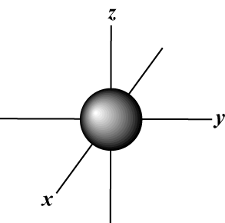

- s-orbital

p-orbitals The p orbital can lie on the x, y or z axis.
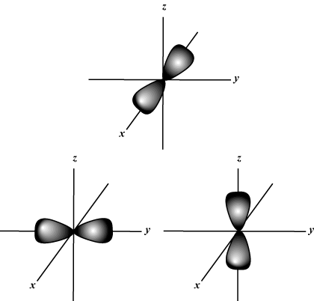

Order of filling orbitals

- The Aufbau principle:

  - Electrons enter the lowest energy orbital available.

- Pauli’s exclusion principle:

- No orbital can accommodate more than two electrons.

- Hund’s rule:

- Orbitals of the same energy are occupied singly before pairing occurs to avoid repulsion.

Exercise C

1 Complete the electronic configuration for the following atoms and label the sub-shells appropriately, using arrows to show the position of the electrons in the corresponding orbitals.
(a) Sodium
Electronic Configuration: 2, 8, 1

Orbitals: ___

___ ___ ___

___

___ ___ ___

2s ___

1s ___

(b) Sulfur

Electronic Configuration:

Orbitals: ___

___ ___ ___

___

___ ___ ___

2s ___

1s ___

(c) Arsenic

Electronic Configuration:

Orbitals:

2 The element potassium is in Group 1 and Period 4 of the Periodic Table.

(a) Write out the electronic configuration for an atom of potassium giving the number
of electrons in each of the principal quantum shells/energy levels (2,8 etc.)

(b) Write out the electronic configuration for an atom of potassium giving the number
of electrons in each of the sub-shells (1s² etc)

(c) Explain the relationship between the electronic configuration of potassium and its position in the Periodic Table.

[4]
3 Write out the full electronic configuration (1s²2s² etc.) for each of the
following atoms and ions.

(a) B
(b) P
(c) Mg²⁺
(d) Co [4]

4 (a) Write out the full electronic configuration using sub-shells of the following
atoms and ions:
(a) S²⁻
(b) Ar
(c) Ca²⁺
(d) Sc³⁺

(b) Explain the meaning of the term isoelectronic.

[5]
5 (a) What is an orbital?

(b) Give the number of electrons found in:
(i) An ‘s’ orbital

- A ‘p’ orbital

(iii) A ‘p’ sub-shell

(c) Draw and name the shape of:

(i) An ‘s’ orbital

(ii) A ‘p’ orbital

[7]
Total [23]
Revision Summary Questions for Electronic Configuration

- State the number of electrons that can fill the first four shells

- What is the electronic configuration of chlorine

- What is an orbital?

- Describe and draw the shape of an s orbital.

- Describe and draw the shape of a p orbital.

- How many orbitals are there in an s, p and d sub-shell respectively?

- How many electrons occupy s, p and d sub-shells respectively?

- In what order are the energy shells and their sub shells filled with electrons according to their increasing relative energies?

- What is the electronic configuration for an atom of potassium?

- What is the electronic configuration for an atom of krypton?

- What is the electronic configuration for an ion of calcium?

- What is the electronic configuration for an ion of arsenic?

- To which block of the Periodic Table would you classify the element argon?

- To which block of the Periodic Table would you classify the element sodium?

Electronic Configuration Additional Exercise 1
- Complete the following table.

Energy sub-level | Maximum number of electrons
s | 2
p | 6
d | 10

2. Listed below are the electronic configurations of five elements, A to E.

One of the configurations is wrong.

A 1s²2s²2p⁶

B 1s²2s²2p⁶3s¹

C 1s²2s²2p⁶3s²3p⁶4s²3d⁶

D 1s²2s²2p⁴3s¹

E 1s²2s¹

- Identify the element with the wrong electronic configuration.

- Which element is a noble gas?

- Which two elements are in the same group of the Periodic table?

- Identify element C

- Why is the 4s sub-shell filled before the 3d sub-shell?

- Divide the elements A to E into s block, p block and d block elements in the Periodic Table.
s:
p:
d:

Electronic Configuration Additional Exercise 2

1. The table gives the electronic configuration of consecutive elements in each of two groups (A and B) of the Periodic Table.

Group A |  | Group B
Element | Electronic Configuration | Element | Electronic Configuration
R | 1s²2s¹ | X | 1s²2s²2p⁴
S | 1s²2s²2p⁶3s¹ | Y
T |  | Z | 1s²2s²2p⁶3s²3p⁶4s²3d¹⁰4p⁴

- Write down the electronic configuration of:

  - T

  - Y

- In which group of the Periodic Table are:

  - R, S and T

  - X, Y and Z

- For the electron in 3s¹, what is meant by 3, s and ¹?

- What is meant by an ‘orbital’?

- What is the maximum number of electrons in a:

  - s orbital

  - p orbital

Electronic Configuration Additional Exercise 1
- Complete the following table.

Energy sub-level | Maximum number of electrons
s | 2
p | 6
d | 10

2. Listed below are the electronic configurations of five elements, A to E.

One of the configurations is wrong.

A 1s²2s²2p⁶

B 1s²2s²2p⁶3s¹

C 1s²2s²2p⁶3s²3p⁶4s²3d⁶

D 1s²2s²2p⁴3s¹

E 1s²2s¹

- Identify the element with the wrong electronic configuration.
Fluorine

- Which element is a noble gas?
A. It is neon

- Which two elements are in the same group of the Periodic table?
B (sodium) and E (lithium)

- Identify element C
Fe

- Why is the 4s sub-shell filled before the 3d sub-shell?
4s subshell is lower in energy than 3d subshell

- Divide the elements A to E into s block, p block and d block elements in the Periodic Table.
s: B and E
p: A and D
d: C

Electronic Configuration Additional Exercise 2

1. The table gives the electronic configuration of consecutive elements in each of two groups (A and B) of the Periodic Table.

Group A |  | Group B
Element | Electronic Configuration | Element | Electronic Configuration
R | 1s²2s¹ | X | 1s²2s²2p⁴
S | 1s²2s²2p⁶3s¹ | Y
T |  | Z | 1s²2s²2p⁶3s²3p⁶4s²3d¹⁰4p⁴

- Write down the electronic configuration of:

  - T

  - Y

- In which group of the Periodic Table are:

  - R, S and T group 1

  - X, Y and Z group 6

- For the electron in 3s¹, what is meant by 3, s and ¹?

- What is meant by an ‘orbital’?

- What is the maximum number of electrons in a:

  - s orbital

  - p orbital

